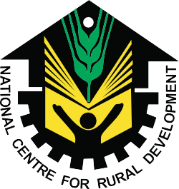

NCRD’s Sterling Institute of Management Studies, Nerul
ALUMNI FEEDBACK FORM

Alumni Full Name
Date of Birth (DD/MM/YY)
Year of Passing out |  |  | Department |  | MMS / MCA
Permanent Address
Contact No. |  |  | Mobile No.
E-mail ID
Present Organization
Designation |  | Present Location

No | Statement | Agree | Sometimes | Disagree
1 | Do you feel proud to be associated with NCRD SIMS as Alumni?
2 | Institute organizes various kind of activities for overall development of students.
3 | Would you like to contribute in the development of the Institute?
4 | Institute handles student’s grievance properly.
5. | Institute is having adequate Infrastructure and equipment for practical experiences.
6. | Is education imparted useful and relevant in your present job?
7. | Have you obtained sufficient technical knowledge (both in theory and practical) at NCRD SIMS?
8. | Has the T & P Cell provided ample On Campus and Off Campus placement opportunities?
9. | Is Institute providing good hospitality as Alumni after passing out?
10. | Do you receive regular updates from the Institute?

Most Memorable moment in the Institute:

Suggestions for Improvement:

DATE: SIGNATURE

